EPWORTH FAMILIES MAY NOW BRING THEIR COMPOSTABLE WASTE TO EPWORTH!

Why should I compost my food waste?
Food waste makes up about 24% of municipal solid waste. In landfills, that waste generates methane, a climate-changing greenhouse gas that is more than 20 times more potent than carbon dioxide.
Composting diverts food and other organic waste from landfills and turns it into a nutrient-rich soil amendment that reduces the need for chemical fertilizers and pesticides.
How does it work?
Collect your food waste in a compostable bag.
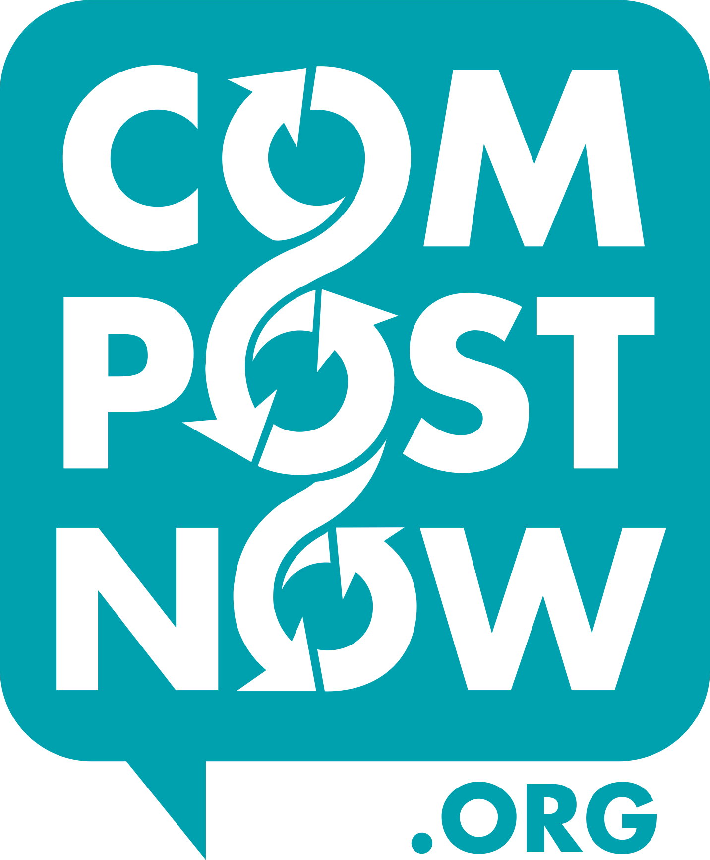
On weekends or after 1PM on weekdays, bring your waste to the black CompostNow containers located between the Preschool buildings.
CompostNow uses your waste to create jobs, fight climate change, and improve the health and resiliency of our local food system!
What waste should I bring?
Fruit and Vegetable Scraps (including fruit pits)
Meat and Fish Scraps (including bones)
Paper Towels and Napkins (not contaminated with cleaning products)
Coffee Grounds, Filters, and Tea Bags (remove the staple first)
Pasta, Bread, Rice, and Cereal
Dairy Products and Eggshells
Nuts and Nut Shells
Empty Pizza Boxes
Wine Corks, Chopsticks, Popsicle Sticks, and other untreated wood
For a more comprehensive list, visit compostnow.org

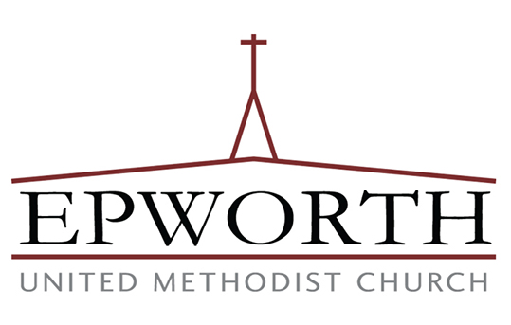
Please consider increasing your regular giving to Epworth by just $5/month to contribute to this creation care ministry.

For your reference, home service costs $29/month.
CompostNow fully supports our model of collecting
compostables together as a church family!

